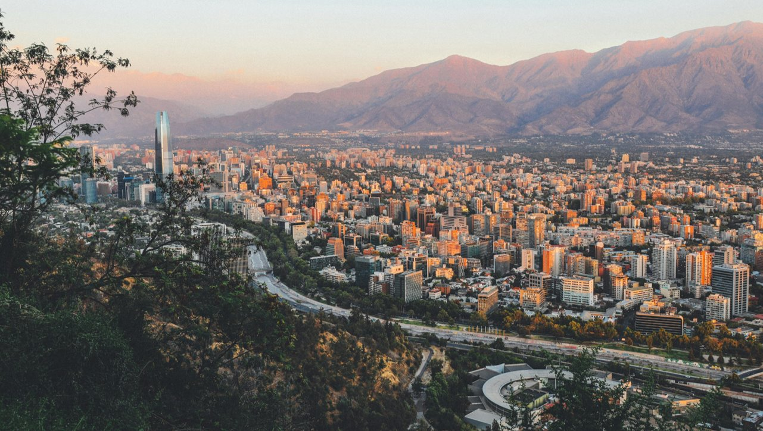

Trip Manual

Santiago, Chile Global Access Partnership

January 4, 2025– January 11, 2025



Table of Contents

COUNTRY INFORMATION 3
Weather 3
Clothing & Accessories 4
Currency 4
Tipping 5
Outlets 5
Crime and Safety 6
TRAVEL INFORMATION 9
HOTEL INFORMATION 24
Delegates 26
Information & Documents 31
Where to eat - Restaurant Recommendations 34
Where to shop - Recommendations 37
What to do - Tourism Information 38

COUNTRY INFORMATION



Country: Chile
- Capital: Santiago
- Official Language: Spanish
- Ethnicity: Predominantly Mestizo, with European and Indigenous influences
- Government: Presidential Republic
- President: Gabriel Boric (as of 2024)
- Prime Minister: Not applicable (Chile does not have a Prime Minister)
- Area: 641 km² (247.6 sq mi)
- Population: Approximately 19 million
- Density: About 9,821 people per km²
- Currency: Chilean Peso (CLP)
- Time Zone: CLST (UTC−3 in summer)
- Date Format: dd/mm/yyyy
- Drives on the: Right
- Country calling code: +56 Area C

Weather
In January, Santiago, Chile typically has a high temperature of 31°C (87.8°F) throughout the month and the possibility of exceeding 33°C (91.4°F). However, daily low temperatures are around 13°C (55.4°F) and can fall below 10°C (50°F) on particularly colder days. You’ll want to bring some warmer clothes for the evening as things do get quite cool, while sea temperatures along the coast are around 18°C (64.4°F). Humidity is low, while average rainfall is minimal, with only about 0.6mm over one day with rain
In general, the climate is Mediterranean, making the area accessible and enjoyable throughout the entire year. January is an ideal month to visit Santiago as it’s warm enough to go sunbathing, swimming, and sightseeing. It is one of the most comfortable months of the year as dew points are neither too dry nor too muggy. (kimkim.com) The months of January and February are also packed with a range of events centered around food, music, dance, and culture. Make sure to check out the annual festival schedule before you book your trip.

Temperature
To convert °C to °F multiply by 1.8 and add 32. To convert °F to °C subtract 32 and multiply by 5/9.

Clothing and Accessories
It is highly encouraged that all those visiting Santiago, Chile takes the time to pack a wardrobe that suits the local climate and cultural norms. While Santiago is generally more relaxed, dressing conservatively is expected when visiting historic neighborhoods and places of worship. It is also important that loose-fitting clothing is worn to show respect. There are expectations when entering churches, such as having shoulders and knees covered.
Since the weather can vary, especially in the wintertime, bring tops that are full-sleeved and bottoms of full length. When packing skirts and dresses, make sure that the length goes past the knee. Light layers are encouraged to ensure you have proper attire for varying temperatures. Swimwear is fine at the hotel pool or beach but not elsewhere.
It is best to pack comfortable walking shoes or light boots for exploring the city, instead of sandals or flip-flops. Heels are acceptable for evenings out, but for long travel days, please be mindful of footwear selection as you may opt for something more comfortable.
While women do not need to always wear a headscarf, it is respectful to carry one when visiting churches or more traditional areas.
DO NOT:
- Wear clothing that is tight-fitting.
- Wear clothing that is revealing.
- Expose collar bones or chest.
- Expose midriffs.
- Expose thighs.
- Wear clothing that is short.
- Wear sleeveless clothing in historic areas.
- Wear see-through clothing.
- Wear t-shirts with rude jokes or potentially insulting messages.

Currency
The official currency in Santiago, Chile is the Chilean Peso (CLP), often symbolized as $. The Chilean Peso is a floating currency, meaning its exchange rate is determined by supply and demand in the private market, with occasional government intervention to ensure stability.
Currency Notes and Coins: The Banco Central de Chile issues the currency, and the following denominations are in circulation:
- Bills: 1,000 CLP, 2,000 CLP, 5,000 CLP, 10,000 CLP, and 20,000 CLP.
- Coins: 10 CLP, 50 CLP, 100 CLP, and 500 CLP

Exchanging Currency: While some places in Santiago may accept US dollars, it is not as common as in other South American countries. It is advisable to exchange your currency at foreign exchange bureaus (casas de cambio) or use ATMs to withdraw local currency. You can find currency exchange services throughout Santiago at the airport and throughout the city.

Using ATMs: ATMs are widely available in Santiago, and they typically dispense larger denominations. It is recommended to carry smaller notes for convenience, especially when traveling outside the main cities
Credit and Debit Cards: Credit and debit cards are widely accepted in Santiago, especially for larger purchases. However, it is always good to have some cash on hand for smaller transactions
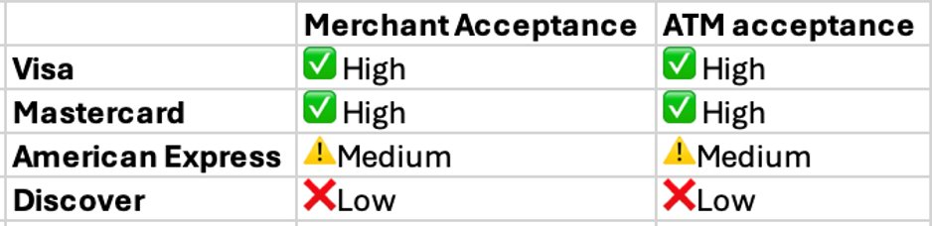

Credit card fees can make a dent when traveling. Credit card issuers typically charge a fee equivalent to 1% to 3% of a transaction. Be sure to review credit card fine print to select a card most suitable Chile.

Tipping
- Restaurants In Santiago, it is customary to tip around 10% of the bill in restaurants. This tip is often included in the bill as a service charge, but you can add more if the service was exceptional
- Spa and Salon Tipping at spas and salons is also common. A tip of 10-15% of the treatment value is customary.
- Bellboys and Valet Drivers: Tipping hotel staff and valet drivers is appreciated but not always expected. Guests typically give around 1,000-2,000 Chilean Pesos (approximately $1.25-$2.50 USD), depending on the service provided.
- Taxi Drivers: Tipping taxi drivers is not very common in Santiago. Most locals do not tip taxi drivers, but rounding up the fare to the nearest 500-1,000 pesos is a nice gesture if the driver was particularly helpful.
- Tour Guides For tour guides, a tip of around 10-20% of the tour cost is customary, depending on the quality of the experience and the overall satisfaction with the tour.
- Airport Porters: At Santiago's airport, tipping porters is customary. A tip of around 1,000-1,500 pesos (approximately $1-1.50 USD) per bag is typical
- Concierge: It is not customary to tip the concierge in Santiago for their help. They are happy to assist with suggestions and bookings without expecting extra remuneration.

Outlets
In Santiago, Chile, the standard plug types are Type C and Type L. Type C plugs have two round pins, while Type L plugs have three round pins in a line. Santiago operates on a 220V supply voltage and 50Hz frequency.

Here is an image featuring a Type C and Type L shaped outlet:
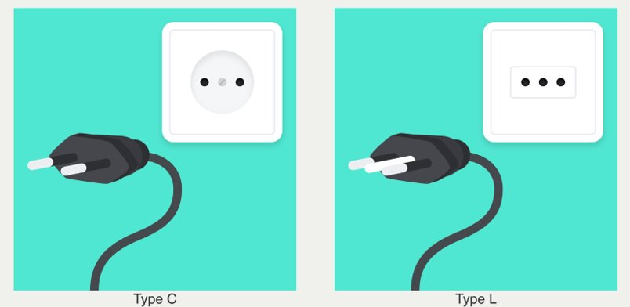

Crime and Safety

General Safety Tips
Santiago, Chile, presents a mixed safety environment for tourists. While it is generally safer than some other Latin American capitals, it is important to stay vigilant.
Here are some basic tips to prepare for your trip, and to help you on the ground in case of an emergency.

Before the Trip

    - Leave any valuables at home for peace of mind
    - Have your medical insurance information with you - and easily accessible
    - Bring any prescription drugs for the duration of your time abroad, and some additional days in case of travel disruption.
    - Make sure any medications comply with local regulations - Check the attachment for any medication restrictions for your destination.

During the Trip

    - Do not carry passports around. Unless required for a specific activity, leave your passport and other valuables locked in the hotel safe until check-out. Carry a photocopy of the passport with you at all times
    - ATMs are recommended to withdraw money.
    - Stay aware of your surroundings at all times. Inform someone where you are going and when you expect to be back.
    - Foreigners can sometimes make easy targets for pickpockets.
    - If you are ever victim of a robbery, do not offer resistance and hand over your belongings calmly.
    - Follow the recommendations of your local on the ground staff regarding the safest means of transportation, available taxi apps, and secure neighborhoods to walk around.
    - Be mindful of your belongings.
      - Do not leave your things unattended
      - Do not hang any bag, coat or other belongings on the back of a chair at a restaurant, café or bar. Do not walk with your phone where it could be easily grabbed
In the event of an incident or emergency during your trip proceed as follows:

    - Communicate with your University Trip Leader and/or Austral Group's local on the ground team to assist you
      - Save any local staff or emergency phone numbers in your phone ahead of time
    - In case a major medical emergency seeks immediate attention - refer to the emergency contact information for verified medical centers in your area.
      - Medical facilities are generally good, but quality can vary in remote areas and may not meet international standards outside urban areas.
    - When requesting assistance, provide the following information:
      - WHO? Identify all individuals involved, yourself and share the name of your University/Program
      - WHAT? Include any important details that can help receive any necessary support
      - WHERE/WHEN? Location and timing of the incident - as precise as possible (city, area, hotel or address if possible)
      - HOW? Be specific in the kind of support you require.

If an emergency arises during your program, please first contact your University Trip Leaders and/or your local on the ground Austral Group staff. If you are unable to reach them - please then reach out to Austral Group’s Emergency Support Team: +1 (863) 261-8020.

Police and Emergency Services: Santiago has a dedicated police force to address issues that tourists may face, such as theft or lost items. In case of emergencies, you can contact the following services:
- 133 – Police
- 131 – Ambulance
- 132 – Fire Department

Common Safety Concerns
- Pickpocketing and Bag Snatching: These are common, especially in crowded areas and public transportation. Keep your belongings secure and avoid displaying valuables
- Mugging: Muggings can occur, particularly at night. It is advisable to take taxis rather than walking alone after dark
- Taxi Scams: Use licensed taxis or ride-hailing services like Uber to avoid scams

Safety Tips
- Stay Alert: Be aware of your surroundings, especially in crowded places.
- Use Licensed Services: Opt for licensed taxis and official tour guides.
- Limit Nighttime Activities: Avoid walking alone at night; use taxis or ride-hailing services.
- Carry Copies of Important Documents: Passport and any other important documents.

TRAVEL INFORMATION

Two luxury cars will transport the group from the University to Orlando International Airport the day of departure and from the Orlando International Airport to the University the day of return.
AIRLINE | FLIGHT NUMBER | DATE | DEPARTURE TIME | DEPARTURE CITY | ARRIVAL TIME | ARRIVAL CITY
COPA | 474 | 1/4/2025 | 2:32 PM | Tampa | 3:39 AM | Santiago
COPA | 475 | 1/11/2025 | 3:28AM | Santiago | 12:41 PM | Tampa

AIRLINE | FLIGHT NUMBER | DATE | DEPARTURE TIME | DEPARTURE CITY | ARRIVAL TIME | ARRIVAL CITY
LATAM | 635 | 1/4/2025 | 8:35 PM | Orlando | 7:00 AM | Santiago
LATAM | 636 | 1/11/2025 | 11:00AM | Santiago | 5:55 PM | Orlando

Cars will be staged at 2:30 PM and depart for the airport at 3:00 PM.

TRIP ITINERARY
January 5 - Sunday


Welcome to Santiago, Chile
Recommended dress code for today: Casual


Tip: Check today's weather report

Today's weather in Santiago


The Team on the Ground
Hi! My name is Patricia Abrigo and I'm your Program Manager for this trip. Alejandra Solano is our local Program Coordinator assisting with the program. She is part of our local team so make sure to reach out to her for recommendations about what to do in your free time, restaurants, and whatever you would like to know about Santiago.
For any emergencies, please contact us at the following numbers (we use WhatsApp)

Patricia Abrigo: +569 94992429

Alejandra Solano: +569 44625668

Patricia Abrigo - Program Manager
+569 94992429

Program Manager

Patricia is a journalist from Universidad Católica de Chile and holds a bachelor´s degree in Hispanic Literature and
Linguistics, from the same university. She has extensive experience working in executive education and international programs, an area she has enjoyed developing professionally. Patricia loves long walks and listening to people´s stories.

Alejandra Solano - Program Coordinator
+56 9 4462 5668

Alejandra is a professional with over 20 years of experience in marketing, sales, public relations, and business development, previously holding leadership in Latin American markets for Inter-Continental Hotels Group, Regus Business Centre and Hurtigruten Cruise Line.

Arrival at Arturo Merino Benitez Airport, Santiago
Once you exit the plane, you will:

- Go through immigration.
- Claim your luggage. (Make sure not to bring ANY fresh food items such as fresh fruit, honey products, or seeds; otherwise, you will be fined).
- Pass through Customs.


Arturo Merino Benítez International Airport
Pudahuel, REGIÓN METROPOLITANA, CL, 9031027
(2) 2690 1752

GROUP TRANSFER TO HOTEL - 45 min - Chile Summer Time

A group transfer will be available for the following flights Arrival al 3.39 AM - Copa Airlines 636
Arrival at 7.00 AM - Latam Airlines 475

Meeting Point: After completing customs and collecting your luggage, pass the sliding doors and an Austral Group Coordinator will be waiting for you with a university sign.

Individual Transfer from Airport Information
If you arrive at a different date/time and do not use the group transfer, please follow these recommendations:

We suggest taking a taxi with the company TAXI OFICIAL or TRANSVIP, both of which are located at the airport after customs. Avoid other transportation services offered by individuals, as they are not authorized and are known to overcharge. Follow the blue arrow labeled "Zona de Compra para Transporte Terrestre Oficial." A private taxi should cost approximately 40 USD or 35,000 CLP.
The Ritz Carlton Hotel is located at El Alcalde 15, Las Condes, about 30 minutes from the airport, depending on traffic.

Check-in at Ritz Carlton

Check in will be available upon arrival

The Ritz Carlton Santiago Chile
15 El Alcalde, Las Condes, Región Metropolitana, CL, 7550655

12:45 PM - Chile Summer Time

Lunch on your own Free Time to Explore

DEPARTURE 5:45 PM - Chile Summer Time

Bus departure to Dean's Happy Hour

6:00 PM - Chile Summer Time

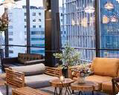
Dean's Welcome Happy Hour

Piso 18 - Double Tree Hotel
2727 Avenida Vitacura, Las Condes, Región Metropolitana, CL, 7550690

Located at the top of the city, “Piso 18” offers an unparalleled panoramic view of Santiago that will captivate you from the first moment. View your events surrounded by the dazzling urban lights and the imposing mountain landscape that only our privileged location can offer.

DEPARTURE 8:00 PM - Chile Summer Time

Bus departure back to the hotel
Estimated time of arrival: 8:20 PM

January 6 - Monday

Destination: Santiago

Recommended dress code for today: Casual, sports


Tip: Check today's weather report

Today's weather in Santiago


9:00 AM - Chile Summer Time Cultural Overview Presentation at the hotel

Ursula Mosqueira

She holds an Ph. D. in Sociology and Masters’ Degree from the University of Washington, Seattle. She is a Human Rights and Gender Consultant, has worked for the United Nations and Universidad Catolica. Her work in the last decade has focused on human rights and gender, especially in the aftermath of authoritarianism in Latin America. She is also dedicated to salsa and West African dance, which she hopes to integrate into her future work with communities overcoming the legacies of political violence.

DEPARTURE 10:15 AM - Chile Summer Time

Bus departure to City Tour
We will depart right after the cultural presentation.

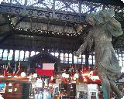
Santiago City Tour

Santiago City Tour

Head to el Centro, the center of the city and Santiago’s historical downtown and original business district. Visit La
Moneda (the Chilean White House), the Plaza de Armas (Santiago’s Central Plaza), and the national cathedral. Stop at St. Lucia Hill, the exact spot where the Spanish founded the city, and its surrounding artsy and European feeling neighborhoods. At each stop, learn about Chilean History and present-day culture or geography.

1:00 PM - Chile Summer Time

Group Lunch

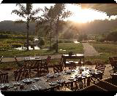
Mestizo
Av. Bicentenario 4050, Vitacura, Metropolitana de Santiago de Chile, CL
+56 9 7477 6093

DEPARTURE 2:30 PM - Chile Summer Time

Bus departure back to the hotel
Estimated time of arrival: 2.45pm

Free Time to Explore the City
Plan ahead and book your exciting activities via our third-party partner at viator HERE.
Viator is a third-party provider for optional activities, please note these are not organized by Austral in any way, and we are not liable for any related issues.


Viator Activities and Tours

DEPARTURE 5:15 PM - Chile Summer Time

Bus departure to the President's Reception

6:00 PM - Chile Summer Time


President's Reception at Casa Gastro Atelier

Casa Gastro Atelier

DEPARTURE 8:30 PM - Chile Summer Time

Bus departure back to the hotel
Estimated time of arrival: 9pm

January 7 - Tuesday

Destination: Santiago

Recommended dress code for today: Business Casual


Tip: Check today's weather report

Today's weather in Santiago

Breakfast at the hotel
Breakfast is served from 6:40 am to 10:30 am at 1st Floor

DEPARTURE 9:00 AM - Chile Summer Time Meet in the lobby ready to depart - Walking We will take a 3-minute walk to Consejo Minero offices.

9:15 AM - Chile Summer Time

Business Meeting: Consejo Minero (Mining Council)


Consejo Minero
3500 Apoquindo Oriente, Santiago, Región Metropolitana, CL
(2) 2233 6242

The Consejo Minero (Mining Council) was founded in 1998 and is comprised of the largest copper, gold, silver, and molybdenum-producing companies currently operating in Chile. They include both national and foreign companies, state- owned and privately owned.

Some of their members are Anglo American, Barrick, BHP Billiton, Codelco, Collahuasi, Glencore, Kinross, Antofagasta Minerals, and Teck. They represent 96% of the national copper production, 50% of the national production of gold, and 60% of the national production of silver.

Carlos Urenda

Mining Council Chile
He is a lawyer and holds a Master's degree in Business Law and a Master's degree in Business Administration from the Pontificia Universidad Católica de Chile.
He previously served as general secretary of the Chilean Chamber of Construction (CChC). He was manager of Corporate Affairs of the electric company Colbún after serving as general manager of the Confederation of Production and Commerce (CPC).

DEPARTURE 10:30 AM - Chile Summer Time

Bus departure to Business Meeting

11:00 AM - Chile Summer Time

Business Meeting: Economic Overview by Banco de Chile


Banco de Chile

Banco de Chile is the second largest financial institution in Chile, after Santander Chile. Banco de Chile is a commercial bank that provides a full range of financial products and services to a broad customer base that includes large corporations as well as small, and medium enterprises. The bank also provides personal banking through a nationwide network of 237 branches, 807 ATMs, and other electronic distribution channels.

Banco de Chile has over 20 years of operational presence in the United States through its branch in New York. It also has a branch in Miami, and a structure of representative offices in Buenos Aires, Mexico City, Hong Kong, and São Paulo, all of which provide international services and products that are suited to the needs of its customers at competitive prices.

Rodrigo Aravena

Chief Economist & Head of Investment Relations at Banco de Chile
He holds a degree in Business Administration from the University of Valparaíso, where he graduated as the top student in economics.
He earned a master’s degree in economics from the University of Chile and an Executive Certificate in Economic Development from Harvard University's Kennedy School of Government.
Since 2014, he has been the Chief Economist at Banco de Chile, overseeing the Investor Relations area.
Previously, he served as Chief Economist for Chile, Peru, and Colombia at Banco Itaú and was Manager of the Research Division and Chief Economist at Banchile Inversiones.
He has been a member of the GDP Trend Advisory Committee convened by the Ministry of Finance since 2008.

DEPARTURE 12:30 PM - Chile Summer Time

Bus departure to Santa Rita Vineyard

1:30 PM - Chile Summer Time

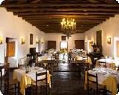
Group Lunch at Santa Rita Vineyard.

Doña Paula

The Doña Paula restaurant, currently part of the Historical Monument, was named in honor of Doña Paula Jaraquemada, who gave shelter to the 120 patriots who fought for the Independence of Chile, more than 200 years ago. Today the house is part of the historical monument and has a colonial style, with white walls on which hang paintings of the Cuzco schools of Quito, and Potosi, among others, high ceilings with bamboo ceilings, exposed beams, and various colonial furniture and objects of the time. All this, in a rural setting with a view of the vineyards and a large corridor that leads to the interior garden.

3:00 PM - Chile Summer Time

Vineyard Visit: Santa Rita
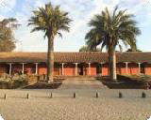
You will have time to visit the Museum and enjoy a Tour and Wine Tasting at the Vineyard.

Santa Rita Vineyard

Viña Santa Rita is located in the Maipo Valley of Chile, an hour from the hotel. Founded in 1880, the vineyard maintains its colonial architecture and tradition.
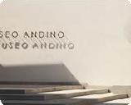
Their wines have been chosen as one of the 100 best premium wine and spirits brands in the world by Luxury Lifestyle Awards.

Museo Andino

DEPARTURE 5:00 PM - Chile Summer Time

Bus departure back to the hotel
Estimated time of arrival: 5:45 pm

Dinner on your own

January 8 - Wednesday

Destination: Santiago

Recommended dress code for today: Business Casual


Tip: Check today's weather report

Today's weather in Santiago

Breakfast at the hotel
Breakfast is served from 6:40 am to 10:30 am at the 1st Floor

DEPARTURE 9:10 AM - Chile Summer Time

Meet in the lobby ready to depart

10:00 AM - Chile Summer Time


Visit to Pontificia Universidad Católica de Chile

Faculty of Economics and Business Administration
4860 Avenida Vicuña Mackenna, Macul, Región Metropolitana, CL, 7820436


With a legacy spanning 100 years, this Faculty is renowned in Chile and Latin America as one of the premier institutions for education and research in economics and business administration. Teaching and research in these fields are central to its academic mission, with a commitment to achieving the highest standards of excellence. Recognized as the top economics school in Latin America, it also ranks among the world’s top 50 according to the QS 2024 ranking.

Jose Miguel Sanchez

Dean

DEPARTURE 12:00 PM - Chile Summer Time

Bus departure to Group Lunch
Location to be confirmed

12:30 PM - Chile Summer Time

Group Lunch (location to be confirmed)

DEPARTURE 2:30 PM - Chile Summer Time

Bus departure to Plant Visit

3:00 PM - Chile Summer Time


Plant Visit: Monarch

Monarch

With more than 80 years in the textile industry, at Monarch we continue to manufacture in Chile.

We are a solid and modern company, recognized for manufacturing quality products, according to the times, needs, and tastes of our customers.

Roberto Aste

Production Manager at Monarch Chile

DEPARTURE 5:00 PM - Chile Summer Time

Bus departure back to the hotel
Estimated time of arrival: 6 pm

Dinner on your own

January 9 - Thursday

Destination: Valparaiso


Recommended dress code for today: Sports Casual Don't forget to bring a hat and use sunscreen

Today´s Weather in Valparaiso

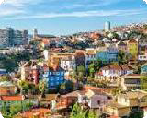
Valparaiso Region
Valparaiso Region, CL

Valparaiso is a major city, seaport, naval base, and educational centre in the commune of Valparaíso, Chile. "Greater Valparaíso" is the second largest metropolitan area in the country. Valparaíso is located about 120 km (75 mi) northwest of Santiago by road and is one of the Pacific Ocean's most important seaports. Valparaíso is the capital of Chile's second most populated administrative region and has been the headquarters for the Chilean Navy since 1817 and the seat of the Chilean National Congress since 1990.

Breakfast at the hotel
Breakfast is served from 6:40am to 10:30am at 1st Floor

DEPARTURE - 2 hr - Chile Summer Time

Bus departure to Valparaiso

10:30 AM - Chile Summer Time

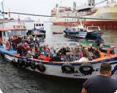
Boat tour in Valparaiso

Boat Tour Valparaíso

A guided boat ride through the bay of Valparaíso, achieving a different perspective of the heritage city from the sea. This boat tour allows unique views from the middle of the sea, with the bay in the background.

DEPARTURE 12:30 PM - Chile Summer Time

Bus departure to Kingston Vineyard

1:30 PM - Chile Summer Time
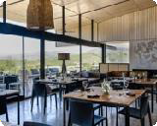
Group Lunch and Wine Tasting at Kingston Vineyard

Kingston Vineyard Dining Room


Tour and Business Presentation at Kingston Vineyard

Kingston Family Vineyards


Today, Kingston Family Vineyards has been recognized as "among the best wineries in Chile" (Stephen Tanzer) and for "making some of Chile's best pinots" (Food & Wine). In 2011, the Kingstons were chosen to host a James Beard dinner in New York City and were named a Winery of the Year by Wine & Spirits Magazine. Their wines have been featured on wine lists at top restaurants including Jean Georges in New York, Boulevard in San Francisco, and the Four Seasons in London. Almost 100 years after C.J. Kingston first ventured to Chile, cows still graze in the fields, gold remains buried deep underground, and the fifth generation of Kingstons grows up surrounded by grapevines in the Casablanca hills.

Courtney Kingston
Santiago, CL

Founder & President
Courtney is a visionary, entrepreneurial leader of her family’s acclaimed winery in Chile’s Casablanca Valley. She challenged conventional wisdom in the mid-1990s by planting red grapes in a cool, coastal region previously only known for whites. Her strategy led Kingston Family wines to become sought after by premier sommeliers and top chefs throughout the Americas and Europe.

DEPARTURE 5:00 PM - Chile Summer Time

Bus departure back to the hotel
Estimated time of arrival: 6:30pm


January 10 - Friday

Destination: Santiago
Recommended dress code for today: Business Casual


Tip: Check today's weather report

Today's weather in Santiago

Breakfast at the hotel
Breakfast is served from 6:40 am to 10:30 am at the 1st Floor

DEPARTURE 9:00 AM - Chile Summer Time

Bus departure to Business Meetings

10:00 AM - Chile Summer Time

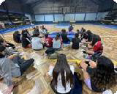
NGO Visit: Fundación Clubes

Fundacion Clubes

Sports NGO, focused on children and young people, seeks to foster community cohesion and promote the comprehensive development of children together with neighbors in poor neighborhoods, through local sports organizations.

12:30 PM - Chile Summer Time

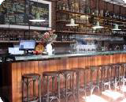
Group Lunch

Casa Luz
805 Avenida Italia, Providencia, Región Metropolitana, CL

Seasonal contemporary menu in an old-school luxurious setting with an amazing back patio!

Time to explore - Recommendations in Barrio Italia
Barrio Italia is an area of low buildings with colorful facades, is dotted with casual Italian restaurants, pizza places, and gelaterias with shaded pavement tables. Paseo Estación Italia is a tiny mall with shops selling local handicrafts and Chilean designer fashions, as well as home decor stores and gourmet food stalls. Relaxed wine and cocktail bars with live music are clustered along Santa Isabel Street

DEPARTURE 4:00 PM - Chile Summer Time

Bus departure back to the hotel
Estimated time of arrival: 4:30 pm

Time to rest and prepare for the farewell dinner

DEPARTURE 5:15 PM - Chile Summer Time

Bus departure to Welcome Dinner

6:00 PM - Chile Summer Time

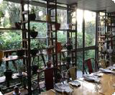
Farewell Dinner at Ambrosia Restaurant

Ambrosia
Pamplona 78, Santiago de Chile, Metropolitana de Santiago de Chile, CL 56 2 2217 3075

A space to enjoy prepared dishes, delicatessen, artisan chocolates, cheeses, charcuterie, and beautiful bouquets of flowers!
About award-winning chef - Carolina Bazán:
After finishing her studies in 2003 she opened with her family the first Ambrosia Restaurant in downtown Santiago.
During the many years of success of Ambrosia in Merced Street Carolina combined work with travel in search of new learning and flavors in different countries such as Peru, Brazil, Italy, and Thailand and finally in 2011 she decided to return to formal studies and spent a year in Paris studying and then working in Frenchie Restaurant, with chef Gregory Marchand.
Back in Chile Carolina started the first Hidden Kitchen movement in Santiago and then in 2013 led the reopening of Ambrosía in a new location and with a new concept. The result is a modern family Bistro, out of the classic gastronomic circuit, where fresh market products drive a menu that changes every day according to what is in season.

DEPARTURE 9:00 PM - Chile Summer Time

Bus departure back to the hotel
Estimated time of arrival at 9:30 pm

January 11 - Saturday

Destination: Santiago

Recommended dress code for today: Business Casual


Tip: Check today's weather report

Today's weather in Santiago

Breakfast at the hotel
Breakfast is served from 6:40 am to 10:30 am at the 1st Floor

Check out before departure

DEPARTURE 8:00 AM -
Bus Transfer to the airport for flights departing at 11 am Bus Transfer to the airport for flights departing at 3:30

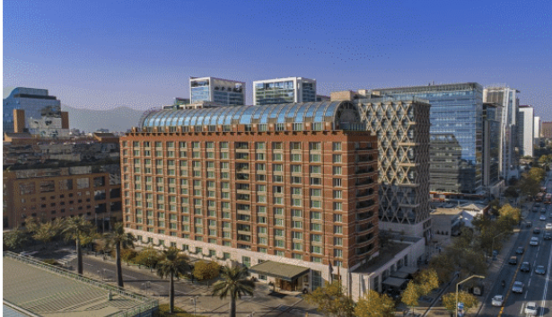
HOTEL INFORMATION

The Ritz-Carlton Santiago
Address: Calle El Alcalde No. 15, Las Condes, Santiago, Chile, 832000
Phone: +56 2 2470 8500

Hotel Dining: Complimentary breakfast every day, included for all guests.
- Estró Restaurant
  - Modern Chilean cuisine
  - Sustainable farm-to-table ingredients
  - Hours:
    - Mon-Fri: 6:30 AM-10:30 AM, 12:30 PM-4:00 PM, 6:30 PM-11:00 PM
    - Sat: 6:30 AM-11:00 AM, 12:30 PM-4:00 PM, 6:30 PM-11:00 PM
    - Sun: 6:30 AM-11:00 AM, 1:00 PM-4:00 PM, 6:30 PM-11:00 PM
  - Dress code: Casual
- The Ritz-Carlton Bar
  - Specializes in Pisco cocktails
  - Cozy and elegant setting
  - Live music on select evenings
  - Hours: Every day: 12:00 PM-1:00 AM
  - Dress code: Casual
- Café Ritual
  - Hand-roasted coffees from Central and South America
  - Sandwiches, salads, and freshly baked cakes
  - Hours:
    - Mon-Fri: 7:30 AM-5:00 PM
    - Sat-Sun: Closed
- The Lobby Lounge
  - Light meals and beverages
  - Live music performances
  - Hours: Every day: 12:00 PM-1:00 AM
  - Dress code: Casual
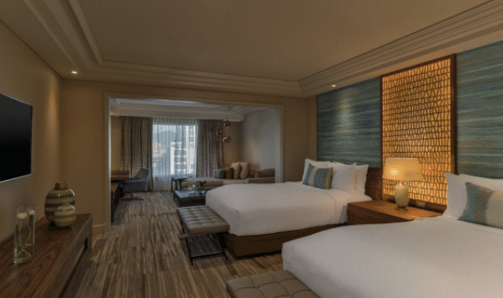
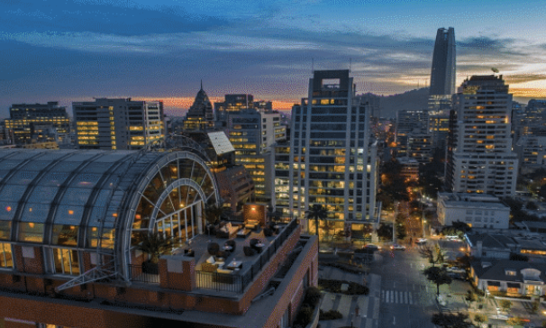

Hotel Amenities:
- Spa treatments
- Indoor lap pool
- Rooftop health and fitness center
- Limo and town car service
- 24-hour currency exchange
- Club Lounge with continuous culinary offerings
- 24-hour room service
- Twice daily housekeeping

The University of Tampa
Global Access Partnership Delegation
January 4th, 2025 – January 11th, 2025

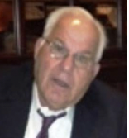
Anthony Borrell Jr. Anthony Borrell was born and raised in Tampa. His mother's family has been in town since 1895, and his father came to town at the young age of 11 from Cuba in 1928. A trustee at UT 16 plus years, Anthony is a retired construction person in the firm his father founded. He has served on bank, credit company, insurance company, state licensing boards, and many non-for-profit boards. He is presently President of the Borrell Family Foundation, which has established two UT scholarships and supported many other causes. Tony is also contributing member of The UT Athletic Hall of Fame and a member of the Trustee Athletic Committee.

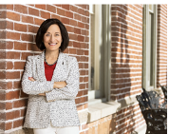
Teresa Abi-Nader Dahlberg Teresa Abi-Nader Dahlberg is the 11th president of the University of Tampa. Dahlberg came to UTampa from Texas Christian University where she served as provost and vice chancellor for academic affairs. In addition to being TCU’s chief academic officer, Dahlberg was also a professor of both computer science and engineering. She has more than 20 years of experience in higher education as a faculty member and an administrator and is known especially as an advocate for student success, innovative academic programs and inclusivity initiatives. At TCU she oversaw the start-up of the Burnett School of Medicine; she increased minority faculty from 16% to 22%; and she served as chief fundraiser for college donors. In her academic career, Dahlberg has been the principal investigator for over $20 million in external funding for projects in the areas of computer education, broadening participation in computing and wireless networking research. Dahlberg began her professional career with the IBM Corporation in North Carolina. She has a bachelor’s degree from the University of Pittsburgh and earned both a master’s degree and a Ph.D. from North Carolina State University, where she is a member of the Alumni Hall of Fame.

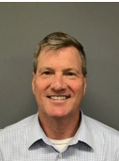
Brian Scott Dahlberg Brian served as a Senior Executive Advisor for Life Cycle Engineering (LCE) from 2016 -2020, where he advised large multinational companies to commence operations of new capital assets with efficient cost-effective processes. Prior to Life Cycle Engineering, Brian was the former Director of Commissioning and Start-Up and Operations Readiness with Alcoa Inc., with over 30 years of experience with multinational and world-class manufacturing. He began his career with Alcoa immediately after graduation from North Carolina State University, retiring in 2015 to utilize his experiences in a consulting role with LCE. Brian earned a Bachelor of Science degree in Electrical Engineering from North Carolina State University and a Master of Business Administration from the University of North Carolina Charlotte. Brian is married to his wife of 37 years, Teresa, who is currently the President of the University of Tampa. They have two children. Nathan is 33 and works on AI development in Manhattan, NY, and his daughter Kristen is 27 and an upcoming 2L law student at the University of Pennsylvania, Carey Law School in Philadelphia.


Don DeFosset Don DeFosset is a member of the Board of Directors of 4 large companies: Regions Financial, National Retail Properties, Terex, and ITT. Mr. DeFosset is also the Chairman of the Executive Board of ATL Partners,a private equity fund in NYC. Mr. DeFosset and his wife, Jan, came to Florida in 2000 when KKR selected him as the Chairman and CEO of publicly traded Walter industries until he retired in late 2005. Previously he worked in senior executive positions with Rockwell International, MackTrucks, AlliedSignal, Navistar, and Dura Automotive. He received his bachelor’s in engineering from Purdue University and an MBA from Harvard University.

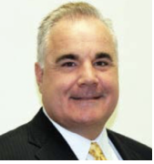
James Eyer James Eyer, Jr. founded Angels Senior Living ("ASL") in 2010 and serves as its CEO. ASL was started in 2010 with two companies. Through development and strategic acquisition, ASL has grown to a family of over 28 companies providing Senior Housing and Healthcare services in the West Coast Florida market. ASL provides services in Assisted Living, Memory Care, Home Health Care, Rehabilitation, Pharmacy, and Insurance. Prior to joining ASL, James served as the Vice President and Senior Director for Life Care Services ("LCS”). Prior to LCS, He served as a Partner and Senior Executive with Accenture, Cap Gemini, and Ernst & Young in their Health Care Consulting Practices. Mr. Eyer is a Certified Public Accountant with accreditation and degree from University of Illinois and Illinois State University. He is an active supporter in the community while serving on many Non-Profit, Financial and Education Institutions Board of Directors and through volunteer work with professional organizations.

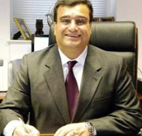
Dr. Frank Ghannadian Dr. Frank Ghannadian is Dean of the Sykes College of Business and Professor of Finance. He is also Director of the TECO Energy Center for Leadership. His academic specialty is in international finance, financial institutions and investing. During his time at UT, he led three AACSB reaffirmations; one in 2008, one in 2013, and one in 2018 for AACSB International, ABET accreditation in 2011, and 2016 for the MIS program. The Sykes College of Business is ranked by Bloomberg Business Week, Princeton Review, and other prestigious ranking groups. Dr. Ghannadian previously served as Interim Dean, Associate Dean, Chief Operating Officer and Professor of Finance at the Stetson School of Business and Economics at Mercer University. While at Mercer, Dr. Ghannadian founded and developed the Executive MBA Program, started two new Master of Science programs, developed various offsite MBA programs, and initiated the School of Business speaker series. Dr. Ghannadian serves on the AACSB Initial Accreditation Committee and serves on a variety of boards in the Tampa Bay region.

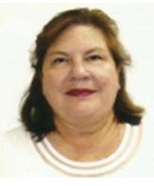
Joni Ghannadian Joni Ghannadian received her Bachelor of Science degree in Nuclear Engineering from the University of Tennessee and Master of Science degree in Technology Management from Mercer University. After over 15 years in the Nuclear Power industry and working for Duke Energy, Bechtel, and a consultant to Georgia Power Company she became a math educator and taught mathematics for the International Baccalaureate (IB) program at Robinson High School in Tampa, Florida. She currently is a lecturer in statistics at the University of Tampa. She has been married to Dr. Frank Ghannadian for over 30 years and they have three children: Jason, Arman, and Ariana.


Charlene A. Gordon Charlene A. Gordon is a University of Tampa Trustee and a leader in local philanthropy for education, arts, health, and disabilities as reflected in her namesake performing arts venue at the University of Tampa. Charlene worked in the information technology field most recently with Pilgrim Quality Solutions, a world-leading provider of Enterprise Risk, Compliance, and Quality Management software solutions for aerospace and other fields. Expert in supporting high-net-worth companies, she also worked for OCE of the Netherlands, Eastman Kodak, and Pitney Bowes.

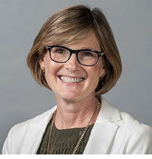
Amy Harris Dr. Amy Harris is the Director of the Graduate Business Programs, as well as the Director of the Nonprofit Management Program and Associate Professor for Management at The University of Tampa. She specializes in strategic management, new venture development, and social entrepreneurship/innovation. Harris graduated from the University of Florida with a B.A. in Sociology, from Florida Atlantic University with an MBA, the University of Florida with a Doctor of Law and from the University of South Carolina with a Ph.D. in Strategic Management/Entrepreneurship.


Mary Beth Holmes Mary Beth is the Director of Corporate Operations for Angels Senior Living and Angels Care Home Health. She hails from Indiana but spent her childhood in Tallahassee. She started her career working in the legal profession before joining Angels Senior Living. James and Mary Beth will celebrate their 10-year anniversary in July and are the proud animal parents to Ming-a-ling, Fiona and Whitney. They enjoy the island life and can be found most weekends on Anna Maria Island.

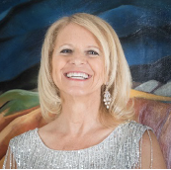
Patricia Kelly Tricia was raised in Ohio as one of eleven children. After graduating from the University of Dayton with a degree in accounting/computer science, she started her career developing accounting software and technology consulting. Having also raised four boys, Tricia is now focusing on being involved in many worthy causes, especially those pertaining to helping underprivileged children. She enjoys the outdoors, traveling, and enjoying the many different activities that life in Tampa Bay provides.


Raymond Kelly Having been born in England to Irish parents, Ray was destined for adventure. Ray started his career as a computer programmer and jumped on the opportunity to work in the USA in the mid-eighties and has since lived and worked in over 100 countries. Prior to retiring as an operating executive in 2018, Ray worked in the technology, education, and finance industries, including running four fast growing companies. He is currently the CEO of Harbour Island Advisors, where he focuses on providing advisory services to venture, private equity, and early-stage companies. Ray has an MBA and a computer science degree from the University of Coventry and is an active board member of several corporate and non-profit boards. Ray likes to travel, play golf, and everything related to soccer.

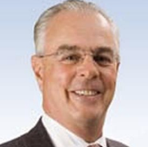
James MacLeod James MacLeod currently serves as non-executive Chairman of CoastalSouth Bancshares, Inc., and its subsidiary CoastalStates Bank. Mr. MacLeod is the former non-executive Chairman of Sykes Enterprises, Inc. (SYKE). He is a Trustee of the Virtus AllianzGI CEF Funds, Chairman of the Performance Committee, and Vice Chair of the MUSC Foundation. Mr. MacLeod holds a Bachelor of Science degree in Economics from The University of Tampa, a Master of City Planning degree in Urban Planning from the Georgia Institute of Technology, and a Master of Science in Real Estate and Urban Affairs from Georgia State University.

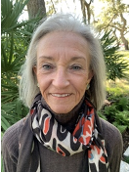
Elizabeth MacLeod Liz MacLeod currently serves on the Spoleto Festival USA Board and is co-chair of the Beaufort County Advisory Board for the South Carolina Governor’s School for Arts and Humanities. She is involved with fundraising and development for those boards. Liz graduated from the University of Tampa in May 2016. Liz lives in Hilton Head Island with her husband and is fortunate to have both daughters and their families also living there. She enjoys exercise, travel, art, and spending time with family and friends.

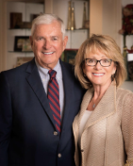
Alexander and Sandy MacKinnon A.D. “Sandy” MacKinnon is the owner of five construction equipment dealerships and recipient of the Philanthropist of the Year and Tampa Bay Ethics Awards, respectively. After founding MacKinnon Equipment & Services in 1982, he pledged to “earn the right to do business with customers each and every day.” In 1982, he purchased the Tampa and Orlando franchise, expanding it to include dealerships in Jacksonville, FL; Tifton, GA; and Ft. Myers, FL

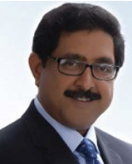
Dr. Hemant Rustogi Dr. Hemant Rustogi is the Dana Professor of Marketing at The University of Tampa and the lead organizer for this delegation. He specializes in business strategy and market analysis and has consulted with numerous businesses and non-profit organizations over a 20-year period. An award-winning teacher, Dr. Rustogi earned a Doctorate in Business Administration from Southern Illinois University at Carbondale, an MBA from Chapman University in Southern California, and a BA in Economics (Honors) from Delhi University in India.

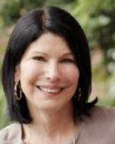
Amy Southard Amy Southard is from Cleveland, Ohio and attended The University of Tampa from 1977-1980 where she met her husband, Michael Southard. She was a restaurant and retail store manager before becoming a stay-at-home mom to their daughters, Ashley and Kasey. Amy is very active in supporting the Boys Hope Girls Hope Foundation in Cleveland. Her grandfather’s brother was from Cuba and made his way along with his family to USA during the Revolution back in the late 50’s early 60’s.

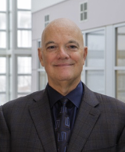
Micheal Southard Michael Southard is a 1982 graduate of the University of Tampa and is currently on the Board of Trustees. Mike and Amy met in the rathskeller while attending UT and have two daughters, Ashley and Kasey. Ashley also attended U of Tampa and graduated in 2012. They currently live in Cleveland, OH the majority of the time but live in Tampa during the winter months. Mike is currently managing director of a private investment firm (Elvisridge Capital) he established in 2018. In his spare time, he enjoys making and collecting wine as well as rooting on Cleveland professional sports teams, and Ohio State University Football.



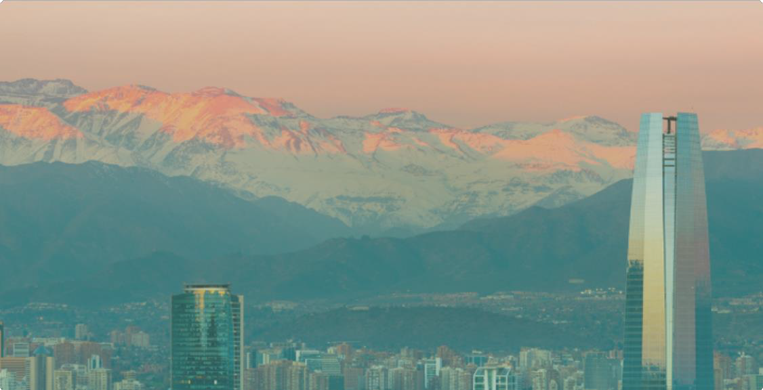
The University of Tampa Trustees January 2025 Chile
Jan 5, 2025 - Jan 11, 2025



Information & Documents

Emergency Phone Numbers

Program Manager
Patricia Abrigo: +56 9 94992429 (also on WhatsApp)

Program Coordinator
Alejandra Solano: +569 4462 5668 (also on WhatsApp)

Police: 133
Ambulance: 131
Fire Brigade: 132

Austral's 24/7 Crisis Team: +1 (863) 261-8020

USA Embassy: +56 22 232 2600
Av. Andres Bello 2800, Las Condes

Clínica Alemana: +56 22 210 1111
Vitacura 5951, Vitacura


Hospital Clinica Alemana
5951 Avenida Vitacura, Vitacura, Región Metropolitana, CL, 13132
+56 22 210 1111


US Embassy in Chile
2800 Avenida Andrés Bello, Las Condes, Región Metropolitana, CL
+56222322600

Austral Group's 24/7 Crisis Team
+1 (863) 261-8020



Dress Code & Clothing
The daily dress code is listed on the itinerary for each day. The dress code will depend on daily activities. In general, visits to companies will require business casual dress. Please be sure to follow these general guidelines:

Business formal
Tie and jacket; suit, slacks or skirt and a blouse

Business casual
Khakis and button-down shirts; slacks or skirt and blouse or (short or long sleeve) polo shirts; slacks, work dress, or skirts (blouse optional).

Factory Visits
Closed toed shoes and long pants are a must, sports shoes are acceptable.

Casual
Jeans and athletic shoes may be worn.

Outdoor
Athletic or outdoor pants suggested. Athletic shoes, hiking boots, or sport sandals.

Check itinerary for daily dress recommendations. Bring clothing appropriate for indicated climate.
A fleece or in-between weather jacket may be recommended.
Comfortable walking shoes are important to have on hand, as walking around to take in the sights is definitely a highlight of any trip!

Cultural Visits

When visiting religious or culturally significant sites, please dress respectfully. It is recommended to wear clothing that covers shoulders and knees. Avoid wearing revealing attire, such as tank tops, shorts, or miniskirts. Comfortable, modest footwear may also be required in some locations.
Bringing a light pashmina or scarf is a good idea, as it can be useful for covering shoulders when needed and for keeping warm in meeting spaces or venues with strong air conditioning and protecting yourself from the sun.
Please note that local customs and traditions may vary, so it's always a good idea to follow any specific guidelines provided at each site.

Santiago - The city
Santiago, the capital and largest city of Chile, is located in a valley between the snow-capped Andes and the Chilean Coastal Cordillera. However, Santiago is not at all the typical Latin American city, tainted with clichés of chaotic metropolises and honking taxis. Rather, the capital of Chile is a mixture of old and new, modern mirror glass towers next to neoclassical cathedrals. Apart from the incredible hospitality of the Chileans, you will be looking for extremes here in vain. Even on your first visit to Santiago, the city will seem familiar to you, which will make you want to return again and again.


Stay Connected on Social Media!

Follow Austral Group on our social media networks for news articles, business insights, free webinars, blog posts, travel tips, and much more!

Austral on Instagram


Austral on Twitter


Austral on Facebook


Austral on LinkedIn


Soak up the Chilean Culture!

What better way to get excited about your trip than to start soaking up the local culture now!

Spotify Chile

Where to eat - Restaurant Recommendations

Santiago - Dining
The cuisine of Chile is characterized by both the preparation methods of the Chilean Indigenous Mapuche culture as well as by the aromatic flavors of the fresh ingredients from land and sea. Stews (cazuelas), wood-fire bread (tortillas de rescoldo), and clams, often baked with parmesan cheese (machas a la parmesana), are just some of the regional specialties, along with classic empanadas, grain or corn-based dishes and tropical fruits.
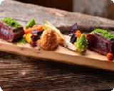
Santiago's cuisine stands out due to its diversity and the mix of modern and traditional dining options. A glass of wine from one of the nearby vineyards will perfectly complement your meal. Wherever you go in Santiago, you will have the opportunity to taste the country's specialties at restaurants and small eateries. Street vendors offer their delicacies at small stalls, their food is generally safe to eat and always delicious.

Peumayén Ancestral Food
Providencia Constitución 136, Santiago


Peumayén Ancestral Food specializes in exploring the roots of Chilean cuisine and prepares its dishes using traditional methods and ingredients. They focus on recreating the tastes of ancestral cultures of pre-Hispanic Chile, serving simplified, minimalist food. If you want to sample all the different flavors of the country, you should order the tasting menu accompanied by some wine from the region.

Boragó
Avenida San José María Escrivá de Balaguer 5970, Chile
+56 22 953 8893

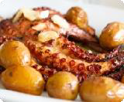
The food at Boragó is prepared using ingredients directly gathered by over 200 small producers throughout Chile, together with their farm-grown vegetables. One of their menus is a tasting experience of the country's traditional dishes over 16 courses, served in stone plates, that can be paired with a selection from their Chilean wine pool.

La Mar
Nueva Costanera 4076, Vitacura
+56 2 2206 7839


La Mar combines Peruvian and Japanese cuisine in creative seafood and fish dishes that you will not find anywhere else in the world. The menu includes local and regional specialties such as ceviche nikkei, locos, picorocos and machas and also serves Japanese sushi dishes such as maki and nigiri.

Zanzibar
6400 Costanera Sur S.J.E. de Balaguer, Vitacura, Región Metropolitana, CL, 7640859

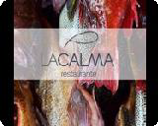
La Calma Seafood Restaurant
Avenida Nueva Costanera, Vitacura, Región Metropolitana, CL

Upscale delicious seafood restaurant with a cozy vibe. Get a taste of what the Chilean coast has to bring to the table!

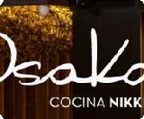
Osaka Santiago
3736 Avenida Nueva Costanera, Vitacura, Región Metropolitana, CL
+56 9 8879 03 42 / +56 2 2617 0882

Santiago - Cafés
Even though many coffee bean varieties are grown in South America, there was no big coffee culture in Chile until only a few decades ago. The hot drink of choice is definitely tea, especially yerba mate – an infusion drink made from cut and dried leaves of the mate shrub. Mate was already popular before the colonization of South America. If coffee is served, you will often get it in small teacups, unlike larger serving sizes customary in Europe or America.

In the 50s, a particular coffee house style established itself in Chile, the Café con Piernas, 'coffee with legs'. In these coffee houses, waitresses work on platforms behind the bar in considerably short skirts. However, despite this questionable feature, these cafés are not uncomfortable or sleazy but furnished elegantly and are located in the main pedestrian areas rather than in hidden side alleyways. No alcohol is served, instead, you will typically find great coffee from hefty espresso machines.

Wonderland Café
Rosal 361, Santiago
+56 9 4340 9729


Wonderland Café is a cozy and authentic retreat hidden in the Barrio Lastarria. An oasis of calm in the city's bustle, where you can relax with a good book and a cup of tea. Try their delicious brunch or indulge in a full English breakfast and fall like Alice through a rabbit hole of delicious food and warming drinks.

Quererte Cafetería
Avenida Cristobal Colon, Santiago
+56 2 2755 1205


Although Quererte Cafeteria is located a bit outside Santiago's city centre, you should definitely check it out! Their fresh cakes and sweet treats are best accompanied by a hot cup of coffee or a delicious smoothie. This is also a great place for lunch, as Quererte have a selection of smaller dishes like avocado toast and wraps available.

Casa Cecilia
3943 Presidente Errázuriz, Las Condes, Región Metropolitana, CL, 7550595

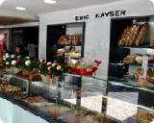
Cecilia Bistró y Café was created by chef Lorena Salinas to bring flavor and joy to the neighborhood. In the mornings you can have a delicious breakfast with that cup of coffee that we all need. In the afternoons and evenings, try the dishes that are lovingly prepared in the kitchen for each person who sits down to share with us.

Eric Kayser

French inspired pastry/bakery


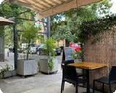
Brunch Recommendations

Recreo con Hambre
1656 Nicolás Gogol, Vitacura, Región Metropolitana, CL, 7650326

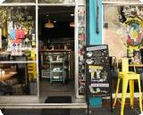
Eggy Coffee Shop
31 Almirante Pastene, Providencia, Región Metropolitana, CL, 7500535

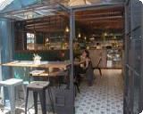
Puelo Cafe

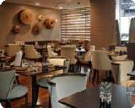
Estró
15 El Alcalde, Las Condes, Región Metropolitana, CL, 7550655


Panera Rosa
3275 Isidora Goyenechea, Las Condes, Región Metropolitana, CL, 7550129

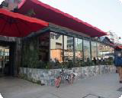
Aligot
2890 Isidora Goyenechea, Las Condes, Región Metropolitana, CL

Where to shop - Recommendations

Santiago - Shopping
Many travel to Santiago just for the sake of shopping. Chile's capital offers well-known, major brands at competitive prices and is especially keen on design, especially interior design, clothing, and electronic devices.
There are several main shopping complexes in the city center, as well as small boutiques selling unique and handmade items.

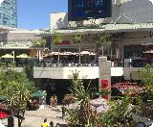
Parque Arauco
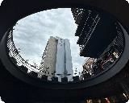
Av. Pdte. Kennedy 5413, Las Condes, Metropolitana de Santiago de Chile, CL, 7560994 22990649

MUT Mercado Urbano Tobalaba
Apoquindo 2850, Las Condes, Metropolitana de Santiago de Chile, CL


Casa Costanera

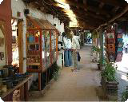
Located in the heart of the Vitacura neighborhood, Casacostanera has more than 80 stores that include fashion, beauty, decoration, entertainment, and the best gastronomic offers. An unmissable panorama in Santiago, convenient for shopping, walking outdoors, and living a boutique experience that makes it unique and full of details.

Los Dominicos Handicraft Village
9085 Apoquindo Oriente, Las Condes, Región Metropolitana, CL

At the foothills of the Andes sits a little artisan’s village, Los Domínicos, renowned for its traditional crafts. This is one of the best markets to visit when searching for souvenirs as it offers almost 200 stalls that sell a variety of folkloric goods, such as leather work, wood crafts, woolen items, jewelry and medicinal herbs as well as some traditional Chilean foods.

What to do - Tourism Information

Santiago - Do & See

As a travel destination, Santiago is often overlooked and misjudged as a layover on the journey to another city in Chile, another country in South America, or another international destination. However, its perfect location between the Andes and the ocean will give you endless opportunities to explore the surrounding nature while Santiago itself will enchant you with a unique mix of ancient tradition and modern influences.

Cerro San Cristóbal / Metropolitan Park
Cerro San Cristóbal

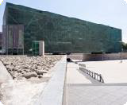
The view from Cerro San Cristóbal is stunning and gives you the most scenic panorama of Santiago imaginable. There are several ways to reach the top of Cerro San Cristóbal to take in this unparalleled view. You can take the funicular that leaves from Bellavista or, if you are a hiking enthusiast, you can hike up Cerro San Cristóbal in about 45 minutes. Either way, try to catch the sunset or sunrise while you are up there and watch the city change from day to night.

Museum of Memory and Human Rights
Avenida Matucana 501, Santiago
+56 2 2597 9600


The Museo de la Memoria y los Derechos Humanos illustrates General Augusto Pinochet's 17-year dictatorship over Chile that resulted in the murder of thousands of Chileans. The museum contributes to the reworking of the period between 1973 and 1990 and at the same time, honors the many victims of the Pinochet rule. It stands as a landmark for the creation of cultural awareness and educates about the terrors of dictatorship.

La Chascona House
Fernando Márquez de La Plata, Santiago
+56 2 2777 8741

La Chascona House was one of the residences of Chilean poet Pablo Neruda. Tours will guide you through the collection of colored glass, shells, furniture and artwork. The unique style of the building reflects Neruda's aesthetic and love of the sea.


Museo Nacional de Bellas Artes
José Miguel de La Barra 650, Santiago
+56 2 2499 1600

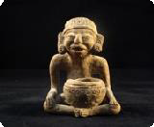
The permanent exhibition of this museum features works of art from the colonial era to the present day. You can see artwork by famous Chilean artists such as Roberto Matta and Luis Vargas Rosas. Although the permanent exhibition is rather small, it is aesthetically pleasing and informative. Rotating feature exhibitions will give you further insights into Chilean art and history.

Museo Chileno de Arte Precolombino
Bandera 361, Santiago
+56 2 2928 1500

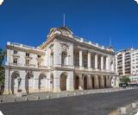
Museo Chileno de Arte Precolombino is located in the city center of Santiago and features exhibits of pre-Columbian artwork and artifacts from Central and South America. This is the perfect opportunity to learn more about the cultures of South America, with a collection covering about 10,000 years.

Teatro Municipal de Santiago
Agustinas 794, Santiago
+56 24631000

The Teatro Municipal de Santiago opened its doors for the first time in September 1857 and has since been considered the most important stage theater and opera house in Chile. The building constructed in the style of neoclassical architecture was inaugurated with the Verdi opera 'Ernani' and has since suffered several strokes of fate, including multiple fires and an earthquake but was reconstructed every time. In 1974, the Teatro Municipal was declared a National Monument.

Santiago - Tourist Information



Passport/Visa

Travelers from all EU countries, the US, Canada, Australia, New Zealand, South Africa and many other Latin American countries do not require a visa to enter Chile for less than 90 days. They will be issued with a Tarjeta de Turismo (tourist card) upon arrival in Chile. You must keep it for when you leave the country. Additionally, Australian and Mexican citizens will be charged a Reciprocity Fee.
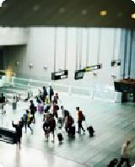
To enter Chile, you must hold a passport that is valid for a minimum of 6 months after your travel dates. Consult with your local embassy or consulate for country-specific information regarding visa regulations.

Arturo Merino Benitez International Airport (SCL)
Arturo Merino Benitez International Airport
+56 2 2690 1796

Arturo Merino Benítez International Airport, also known as Santiago International Airport and Nuevo Pudahuel Airport, is located in Pudahuel, 15 km northwest of downtown Santiago. It is Chile's largest and busiest international airport.
Centro Puerto offers a shuttle service that will take you from the airport to the city and back. You can find a Delfos counter at the airport where you can book shared and private transport.

It can be a bit difficult to get to the airport with public transportation so you might want to look into booking a taxi in advance.

Public Transport
+56 800 73 00 73

A unified payment system, the Bip!, is used to buy tickets for buses, metro, and micros. You can buy and top up a Bip! card in subway stations.
Ticket prices for Metro vary according to your travel schedule, the bus costs the same at any time of day. There are different rates for adults, students, and the elderly.

On weekdays, Santiago Metro runs from 5.40 am to 11 pm, 6.30 am to 11 pm on Saturdays and 8 am to 10.30 pm on Sundays and public holidays.

Taxi

To ensure your safety, it is advised that you only travel in authorized taxis and ignore the taxi drivers and representatives that wait in the baggage claim area of Santiago airport. Authorized, metered taxis are all black with yellow roofs.
There is a taxi rank outside the main terminal, so pre-booking should generally not be necessary. If you do wish to prebook a taxi with a fixed rate to take you to the city from the airport, you can call Vía Controlada: +56 9 4273 2887 or Taxi Oficial:
+56 2601 9880, both operate 24 hours.
For longer rides, you can sometimes negotiate flat fares if your negotiation skills in Spanish are confident enough.

If you want to avoid hailing a taxi in the street (which is generally safe), most hotels and restaurants will happily call you a taxi too. There is also the option to order an Uber.



Pharmacy
Farmacias Salcobrand - Avenida Manuel Montt 1140, Santiago
+56 600 360 6000

There are several pharmacies in and around the city center, some of which operate 24 hours. Most bigger pharmacies have English-speaking staff available.


Post Office
CorreosChile - Plaza de Armas 989, Santiago

You will find several post offices spread throughout the city. The Central Post Office is located in a historic post office building on the northern edge of the Plaza de Armas.

